VHI WOMENS MINI MARATHON 2020

Sign up now and go that extra mile for PSPA Ireland
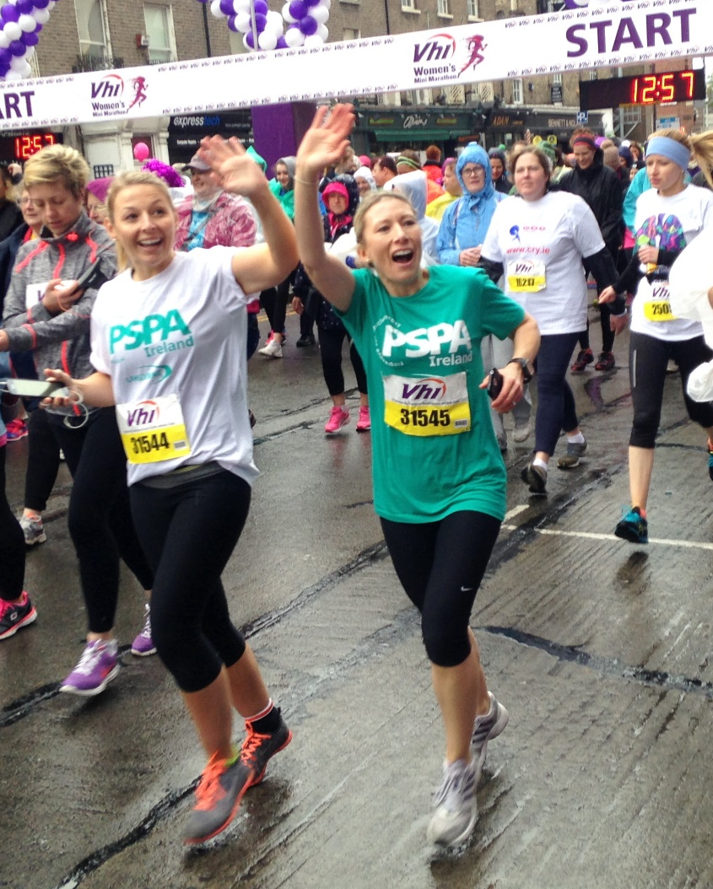

Run, Jog or Walk on
Sunday, 31st May 2020
Start: Fitzwilliam Place
Dublin 2 at 2pm

Finish: Baggot Street
Lower, Dublin 2

Distance: 10K

How do I get started?
1) Register on https://www.vhiwomensminimarathon.ie/
or fill out and submit the entry form in The Herald on Wednesday and
Saturdays. Entry Fee €25 by cheque, postal order or credit card.

2) Contact us for your information pack at info@pspaireland.ie
or phone: 087 3821377. We are happy to advise you with your
fundraising plan and promote your efforts.

3) Make a plan and start training for a great event.

Thank you for your support.

