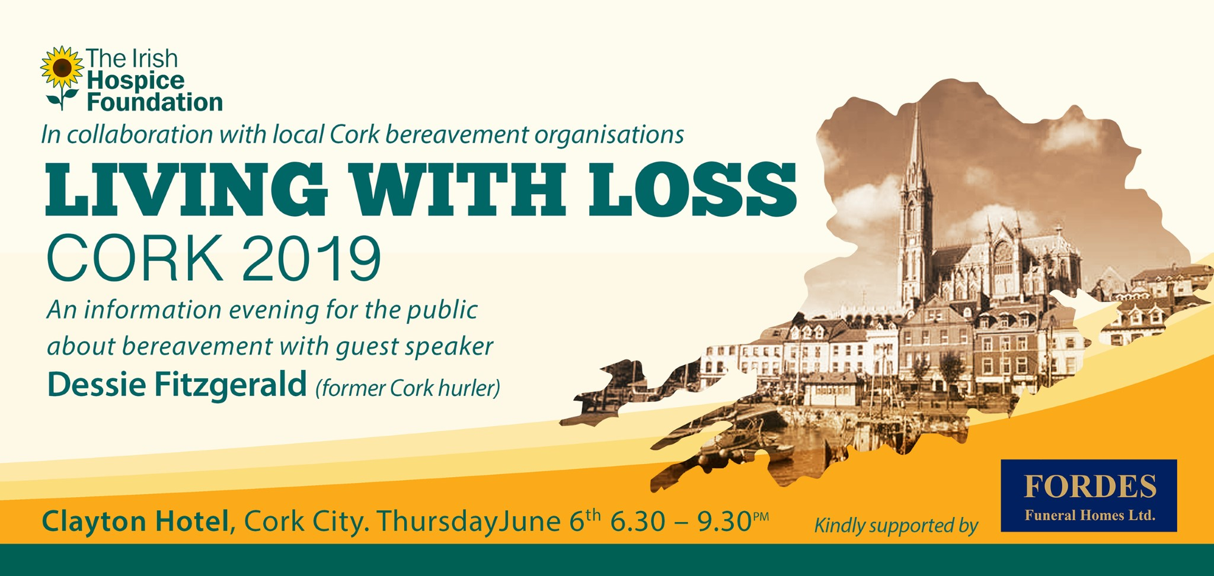
The Irish Hospice Foundation will host its first ever regional Living with Loss Bereavement Information event in Cork this June. This free event for the public will provide information about grief and the range of supports available to bereaved people in the local area. The event is for people bereaved through any circumstance – through illness or sudden death; who may have lost a partner, parent, child, friend or sibling.
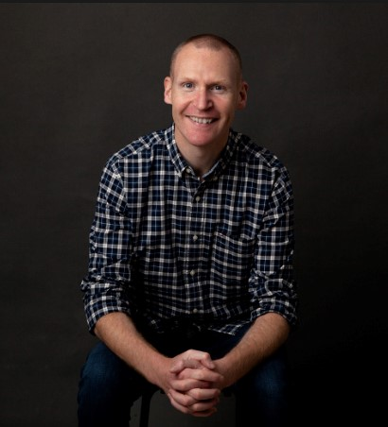
Former Cork hurler Dessie Fitzgerald will be our guest speaker. Dessie has opened up in the media in the past about the devastating loss of his two brothers. He was most recently invited to tell his story on the Late Late Show in May. We are pleased that Dessie will share his story at our Living with Loss event.
The evening will begin at 6.30pm. Professionals who work in the area of bereavement in Cork will talk about the process of grief and the ways we can support each other. The talks will include information about the ways children grieve and how the adults in their lives can support them. There are also opportunities for interaction and questions.
A number of local voluntary bereavement support services and professional therapeutic services will be represented at the event (see list below for the organisations’ confirmed to date). Refreshments will be available and people will have an opportunity to visit the different organisation stands and find out about the services they provide.
This is a free event and booking is not required. Street parking is free from 6.30pm. Parking is also available at Lapps Quay Public Car Park located in the basement of Clayton Hotel.
The event is hosted by Irish Hospice Foundation in collaboration with local Cork bereavement support organisations. The event is kindly sponsored by Fordes Funeral Homes, Cork.
For more information about the event please visit www.hospicefoundation.ie
For more information about venue please visit: www.claytonhotelcorkcity.com
Please contact Amanda at amanda.roberts@hospicefoundation.ie if you have any questions about the event.
Organisations confirmed to date include: Anam Cara, Barnardos, Bethany Bereavement Support, CanTalk, Citizen Information Service, Coisceim Counselling Programme, Cork Counselling Service, Cork North Community Work Department, Cork University Hospital, Cork University Maternity Hospital, Diocese of Cork & Ross, Embrace Farm, Feileacain, FirstLight, Irish Hospice Foundation, Irish Road Victims Association, Marymount Hospice, Mercy Hospital, Pieta House, Suicide Prevention Resource Office, Support After Homicide, The Miscarriage Association.

